[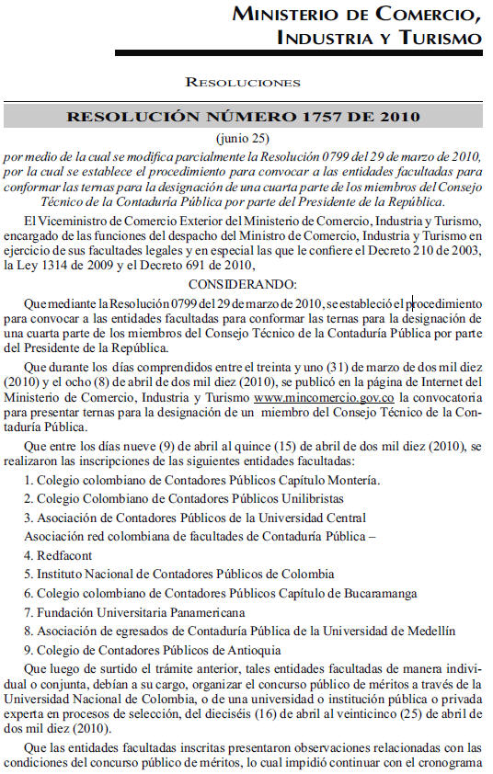](http://www.actualicese.com/normatividad/2008/Decretos/11.jpg)

[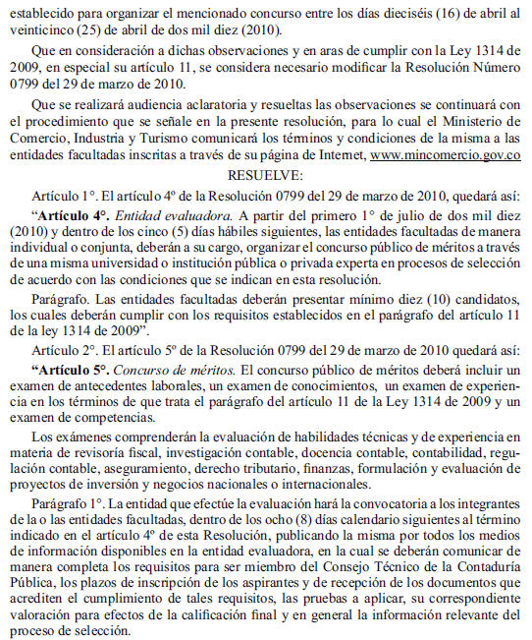](http://www.actualicese.com/normatividad/2008/Decretos/2.jpg)

[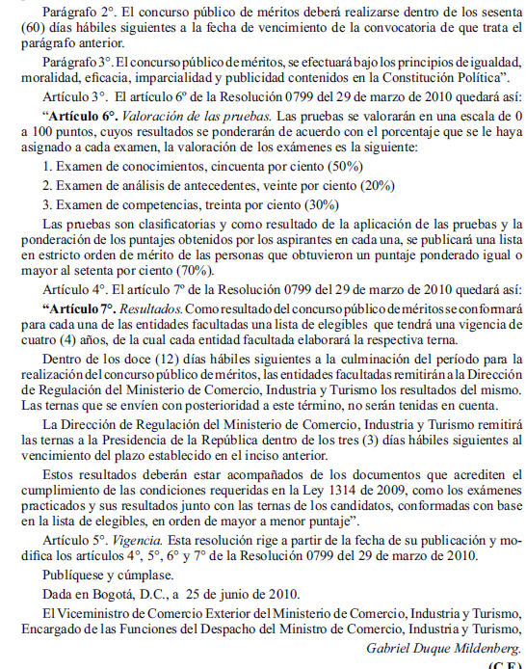](http://www.actualicese.com/normatividad/2008/Decretos/3.jpg)